|  |  |
| --- | --- |
| Leah Rampono | 20231562 |
| Guruprasaath Gopalakrishnan | 20231284 |
| Abinash Vibin | 20231246 |

Abstract

[Draw your reader in with an engaging abstract. It is typically a short summary of the document.   
When you’re ready to add your content, just click here and start typing.]

Planning document

Requirements analysis and Planning

Table of Contents

Project Overview: 2

Project Methodology: 2

Iteration Breakdown and Timeline: 2

Knaban / Project Planner 3

Iteration 1: Developing System Design document 3

Iteration 2: Developing the Database 3

Iteration 3: Developing Database Queries 4

Iteration 4: Implementing Database using Web Application 4

# Project Overview:

The goal of this project is to develop a digital resource for school students. This project involves developing a database and a web application that allows the users (Administrators, Tutors, and Students) to interact with the educational resources across three subjects (Art, Mathematics, and Technology). The educational resources include biographies, major works, concepts, and historical events. The web application will support role-based access to users with an efficient user experience.

# Project Methodology:

As stated in the assignment overview the project will follow an agile development process that will follow through four iterations, where each iteration will have a review session where feedback will be given along with approval. Each task within this project will be broken down into small deliverables and tracked using the Monday.com kanban board which allows for tasks to be assigned to team members and viewing what stage the given tasks are at. Work will be divided and overseen by members on the team based on their strengths.

* Leah will oversee the documentation
* Guru will oversee the creation of the MongoDB database
* Abinash will oversee the testing

# Iteration Breakdown and Timeline:

Below is a table showing the iteration breakdown and timeline for this project:

|  |  |  |
| --- | --- | --- |
| **Iteration** | **Dates** | **Tasks** |
| **Iteration 1** | June 16 – June 17 | * Planning document * System design document (Tech Stack) * UX design |
| **Iteration 2** | June 18 – June 21 | * Database implementation * Data integration * Scheme creation |
| **Iteration 3** | June 23 – June 26 | * MongoDB queries for admin, tutor, student * CRUD operations |
| **Iteration 4** | June 27 – July 1 | * Web application * Frontend interface * Authentication * Full integration |

Table 1: Iteration breakdown and timeline for project completion

# Knaban / Project Planner

## Iteration 1: Developing System Design document

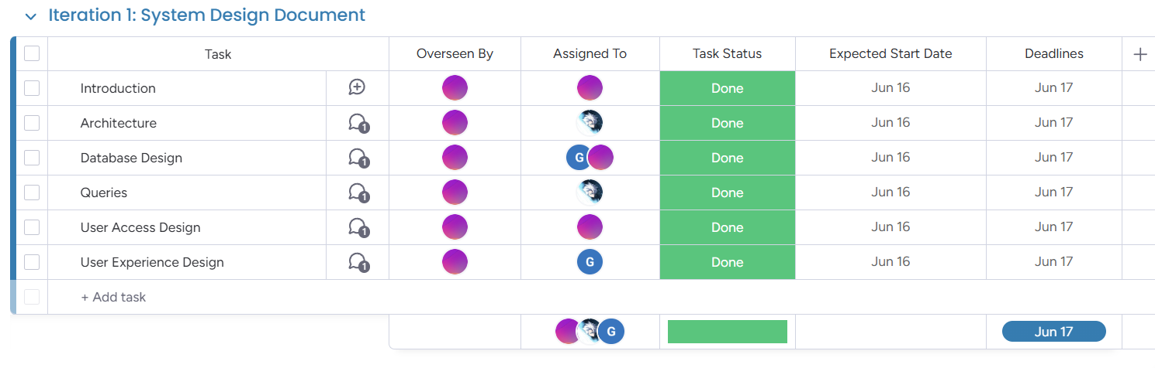

* This iteration will be from 16th June to 17th June
* This iteration will be overseen by Leah
* The iteration was completed on the 19th of June

## Iteration 2: Developing the Database

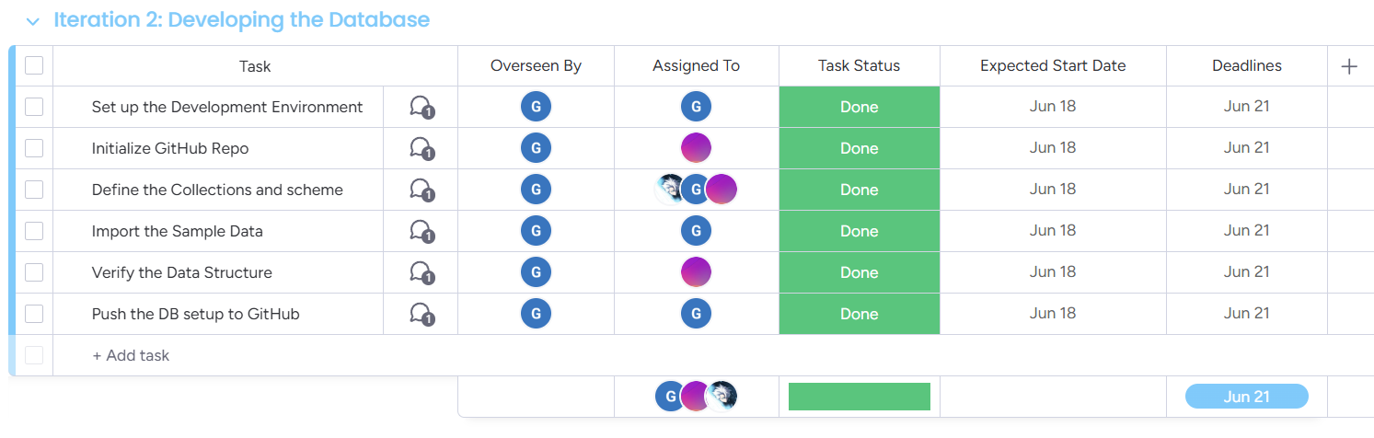

* This iteration will be from 18th June to 21st June
* This iteration will be overseen by Guru
* The iteration was completed on the 26th of June.

## Iteration 3: Developing Database Queries

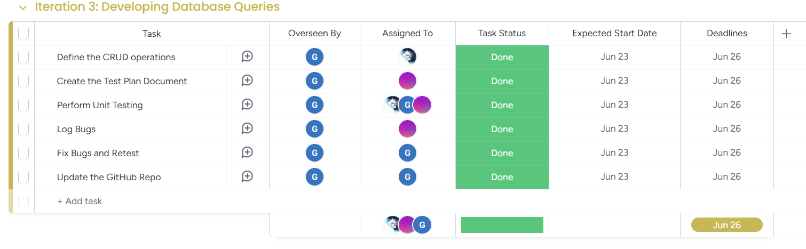

* This iteration will be from 23rd June to 26th June
* This iteration will be overseen by Abinash
* This iteration was completed on the 26th of June as expected.

## Iteration 4: Implementing Database using Web Application

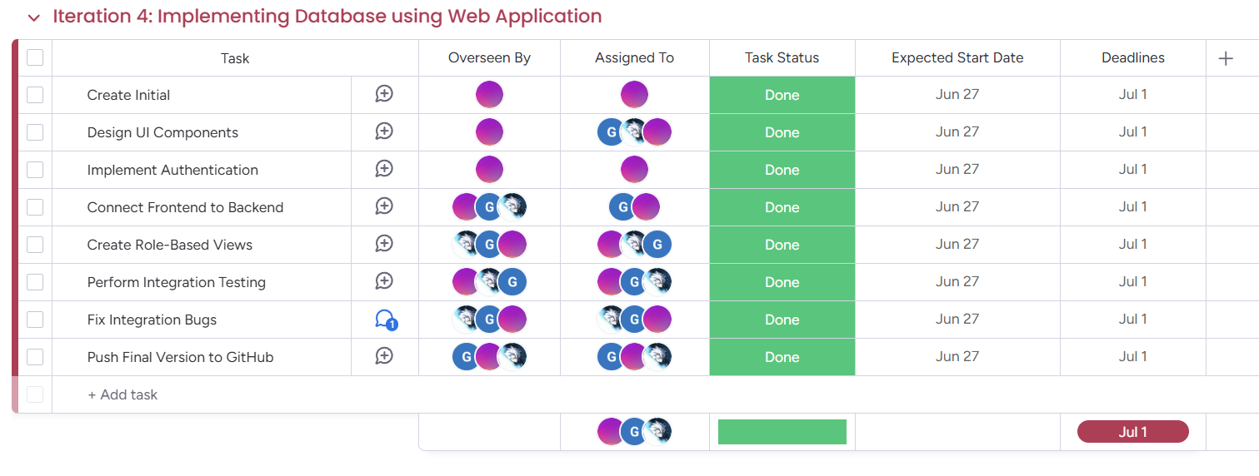

* This iteration will be from 27th June to 1st July
* This iteration will be overseen by various members of the group
* This iteration was completed on the 3rd of June.